WIFLE MEMBERS-ONLY SCHOLARSHIP PROGRAM BACKGROUND
February 1, 2024

In 2008, the WIFLE Foundation established a “Members-Only” scholarship open to regular and associate members of Women in Federal Law Enforcement, Inc. The yearly scholarship is for $3,000 and is selected from the total number of member and member-sponsored applications received yearly. This scholarship was created to encourage WIFLE members to become mentors and reach out to students considering a career in law enforcement or students currently pursuing a degree in a related field. This scholarship also encourages scholarship applications from our present student members working full-time law enforcement jobs and pursuing a graduate degree at an accredited online university, which also incorporates a two-week residency program.

Current WIFLE Members may sponsor either themselves or one individual for this scholarship using the Members-Only Scholarship Application who meets the criteria below.

MEMBERS-ONLY SPONSORED SCHOLARSHIP PROGRAM

Eligibility: Only those applicants sponsored by a WIFLE member. WIFLE members sponsoring themselves must hold current membership. An applicant must also meet the following eligibility criteria as it pertains to their status:

- Attending a full-time accredited four-year college or university or is currently enrolled full-time in a fully accredited community college with the intention of transferring to a four-year degree program. If pursuing a graduate degree, the applicant must carry at least six (6) semester hours; OR WIFLE members working full-time law enforcement jobs pursuing a postgraduate degree at an accredited online university that incorporates a two-week residency program.
- Completed at least one full academic year of college work at an accredited college, university, or community college;
- Maintain a minimum 3.0 overall grade point average (GPA);
- Major in Criminal Justice or a related discipline, such as social sciences, public administration, computer science, finance, linguistic arts, chemistry, physics, etc., leading to a four-year degree (Students in graduate and postgraduate programs are also eligible; students pursuing Associate degrees are not eligible, unless as stated above, fully articulate in the application their intention to transfer to a four-year program.)
- WIFLE members sponsoring their own application and are enrolled in either a graduate program physically attending during off-duty hours or an accredited online university program with a two-week residency program must describe the relevancy of their degree to law enforcement.
- Submit a letter demonstrating their financial need and including a statement of career objectives.
- Provide at least one letter of recommendation from a local community member and/or leader or law enforcement professional.
- Be a citizen of the United States.

Note: Members-only sponsored scholarships are not open to current employees and/or current
officers of the WIFLE Foundation, Inc. and/or Women in Federal Law Enforcement, Inc.

MEMBERS-ONLY SCHOLARSHIP APPLICATION PROCESS

Information on Members-Only scholarship applications is available through the WIFLE website at https://wiflefoundation.org/scholarships/

Submissions should include the scholarship application, college transcripts, letter/statement, and recommendation(s). Applications must be received by the Scholarship Coordinator by May 1, 2024. Extensions will not be granted. Applications that are incomplete or received after the deadline will not be considered.

Recipients will be notified by May 20, 2024, and awards will be mailed directly to the educational institutions.

For answers to specific questions, contact WIFLE by email at WIFLE@comcast.net. Mail applications to:

WIFLE
Attention: Scholarship Coordinator
2200 Wilson Blvd.
Suite 102 PMB 204
Arlington, VA 22201

Or scan and email completed packages to WIFLE@comcast.net.

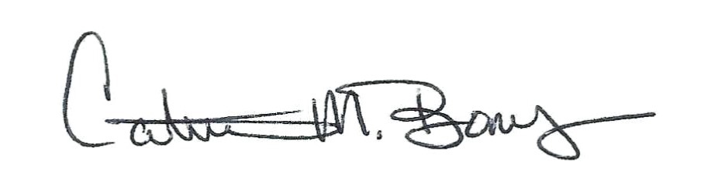
Sincerely
Catrina M. Bonus
President, WIFLE Foundation, Inc.
Executive Director, Women in Federal Law Enforcement, Inc.

WOMEN IN FEDERAL LAW ENFORCEMENT MEMBERS-ONLY
SCHOLARSHIP APPLICATION – 2024

Name: _________________________________________________________________

Address: _________________________________________________________________

_________________________________________________________________

Work #: ______________________ Home #: _______________________Cell #: ___________________

E-Mail Address: ___________________________________________________________

Current Occupation, if employed: _____________________________________________

U.S. Citizen: Yes _____ No _____ WIFLE Membership No. ________________________

Name of College or University attending: ______________________________________________

Full-time Student: Yes _____ No _____ Physically Attending ______ Online Program _________

Major: __________________________________________________________________________

Total Credit completed to date: __________________ Grade Point Average (GPA): ___________________

Note: Provide College transcripts to substantiate GPA

Expected Date of Graduation: _______________

Name of WIFLE Member sponsoring application: _____________________________________________

Signature of WIFLE Member sponsoring application: __________________________________________

Complete this application and submit it with your 500-word essay, college transcripts, and sponsor’s letter of recommendation. Forward all materials to:
WIFLE
Attention: Scholarship Coordinator
2200 Wilson Blvd.
Suite 102 PMB 204
Arlington, VA 22201
or
wifle@comcast.net

The application and all related materials must be received no later than May 1, 2024, to be considered.

Applicant’s Signature: __________________________________________Date: ___________________

